**SAL EDUCATION**

**SAL INSTITUTE OF DIPLOMA STUDIES**

Opp. Science city, Sola-Bhadaj Road, Ahmedabad, Gujarat 380060 Ph: - 079 67129000 Website: www.sal.edu.in



**DEPARTMENT OF COMPUTER ENGINEERING DEPARTMENT OF INFORMATION TECHNOLOGY**

**SEMESTER-3**

# SUMMER INTERNSHIP WEEKLY ACTIVITY STATUS REPORT

**STUDENT NAME :** Malvi Krutika Rasheshbhai

**ENTROLLMENT NUMBER :** 224510307064

**COMPANY NAME :** Brainy Beam

**COMPANY LOCATION:** F6, dhanlakshmi chambers, near sarvoday co - op bank. Ashram road, Ahmedabad.380014

**NAME OF INTERNAL GUIDE:** Paresh Katheriya

**NAME OF EXTERNAL GUIDE:** Sagar Jasani

**INTERNSHIP PERIOD: FROM DATE** : 10/08/2023 **TO DATE :** 23/08/2023

# SAL INSTITUTE OF DIPLOMA STUDEIS

## DEPARTMENT OF COMPUTER ENGINEERING DEPARTMENT OF INFORMATION TECHNOLOGY

**WEEK 1**

### FROM DATE: 10/08/23 TO DATE: 16/08/23

# DAY 1

**DATE:** 10/08/23

**DAY:**  Thursday

* **Details of activity performed:**
* **Task:** Create a simple HTML page.
* **Code:**

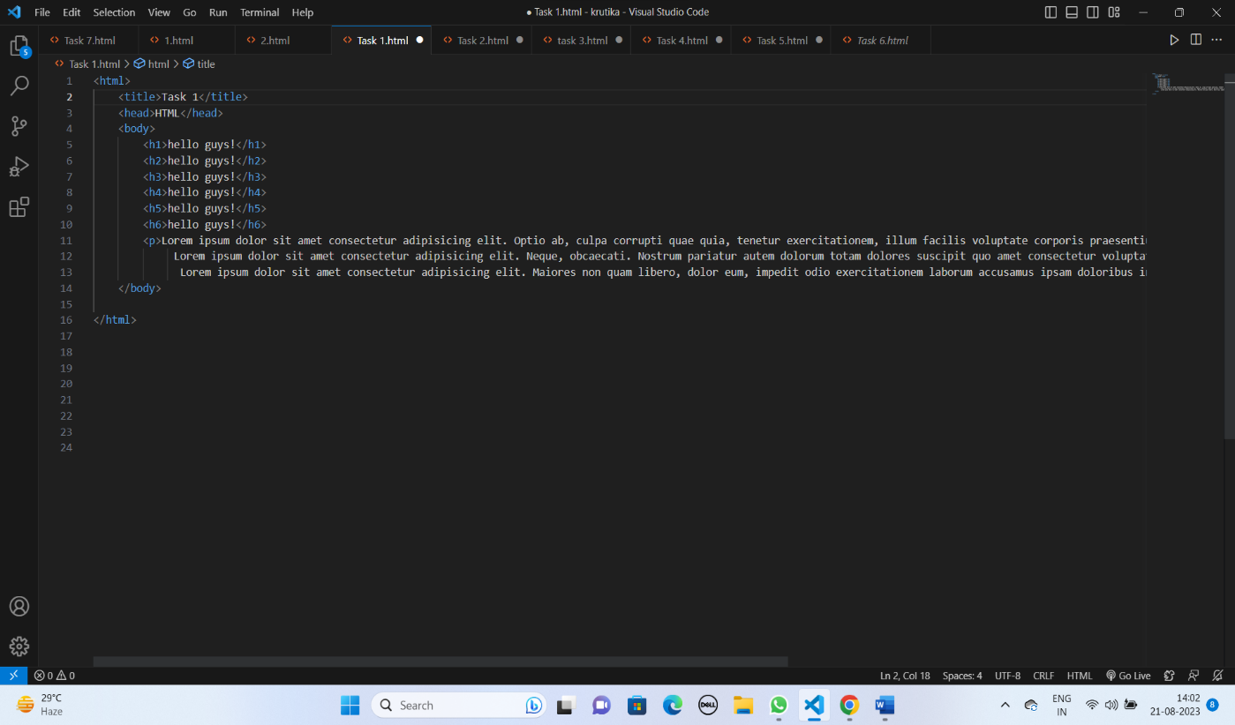

* **Output:**

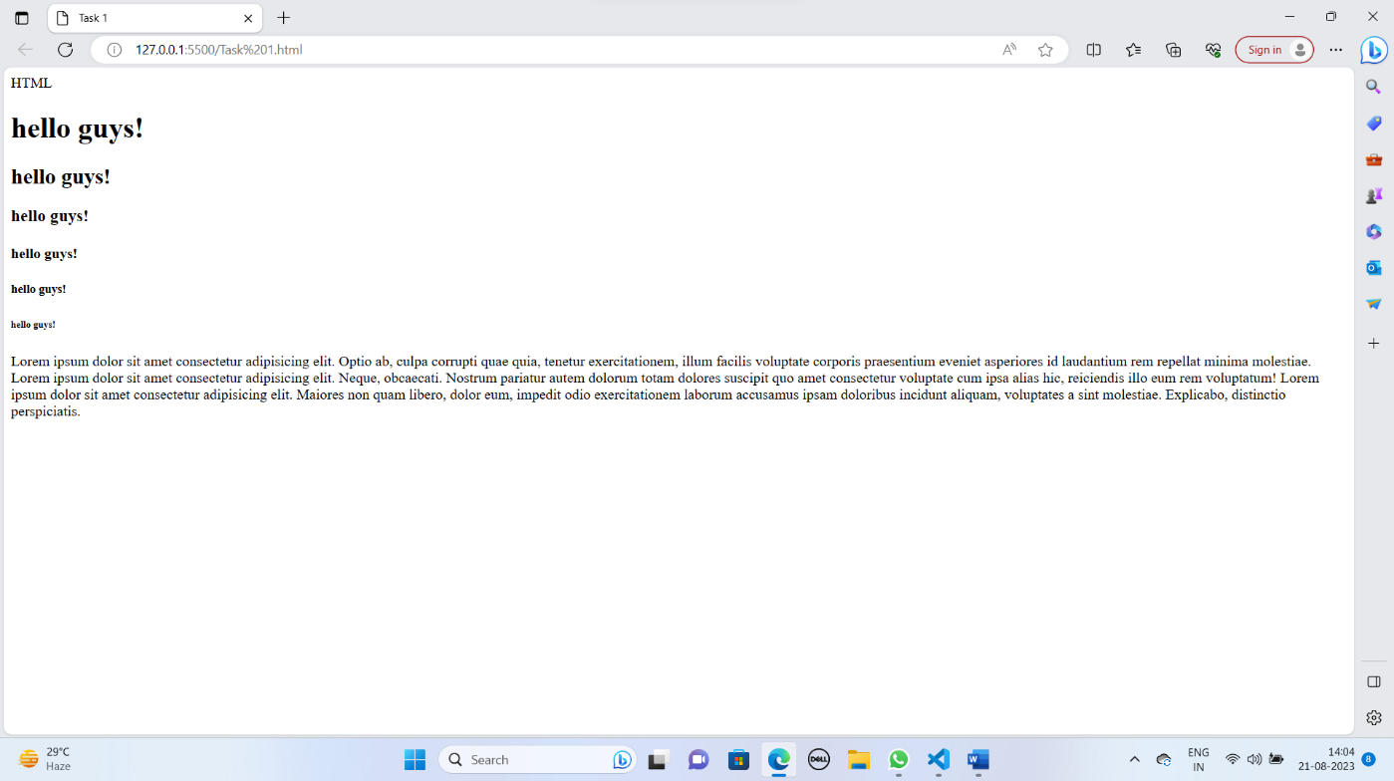

* **Discription:**
* HTML (Hypertext Markup Language) is the standard markup language used to create web pages. HTML documents consist of a series of elements, which are defined by tags. These tags are used to structure the content on a web page and provide information about how the content should be displayed.
* <html>: The root element that wraps the entire HTML document.
* <head>: Contains metadata about the document, such as the page title.
* <title>: Sets the title of the web page, which appears in the browser's title bar or tab.
* <body>: Contains the visible content of the web page.
* <h1>, <h2>, <h3>, <h4>, <h5>, <h6>: Headings of various levels, with <h1> being the highest and <h6> the lowest.
* <p>: Defines a paragraph of text.

# DAY 2

**DATE:** 11/08/23

**DAY:** Friday

* **Details of activity performed:**
* **Task:** Create a Time table using Html tags.
* **Code:**

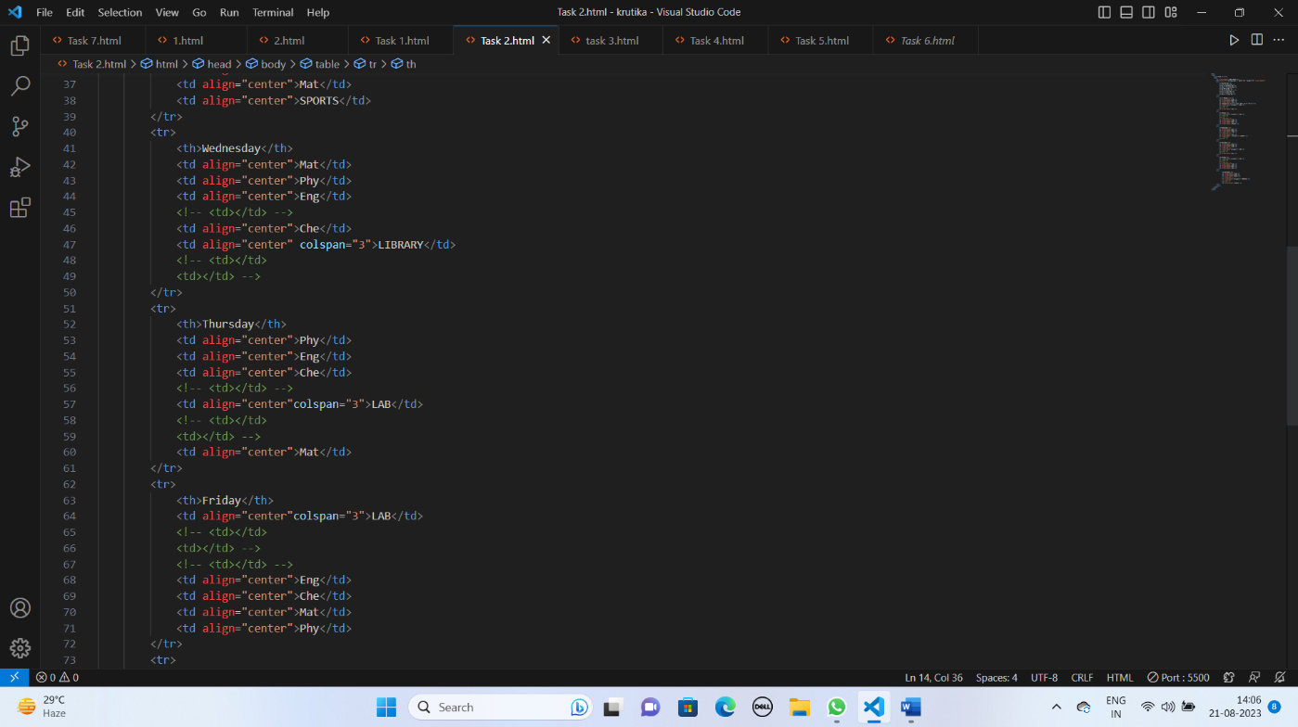

* **Output:**

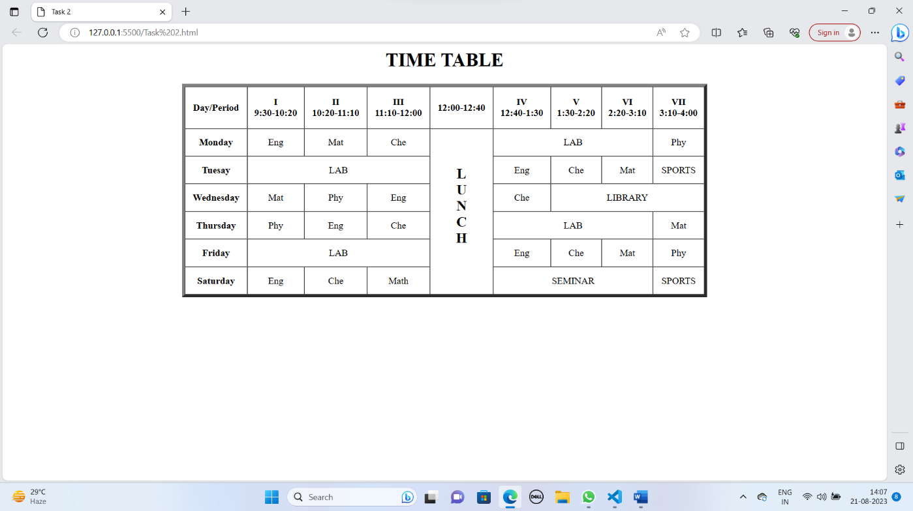

* **Discription:-**
* <table>: This tag defines the beginning of an HTML table. All table-related content, such as rows and cells, is enclosed within this element.
* <tr> (Table Row): <tr> is used to define a table row. Rows contain one or more table data cells or table header cells.
* <th> (Table Header Cell): <th> is used to define a table header cell. Header cells are typically used in the first row or column of a table to label or describe the content in the cells below or to the right.
* <td> (Table Data Cell): <td> is used to define a table data cell. These cells contain the actual data or content of the table, such as text, numbers, or other HTML elements.
* <br>: Inserts a line break.

# DAY 3

**DATE:** 12/08/23

**DAY:** Saturday

* **Details of activity performed:**
* **Task:** Create a form by using some HTML tags.
* **Code:**

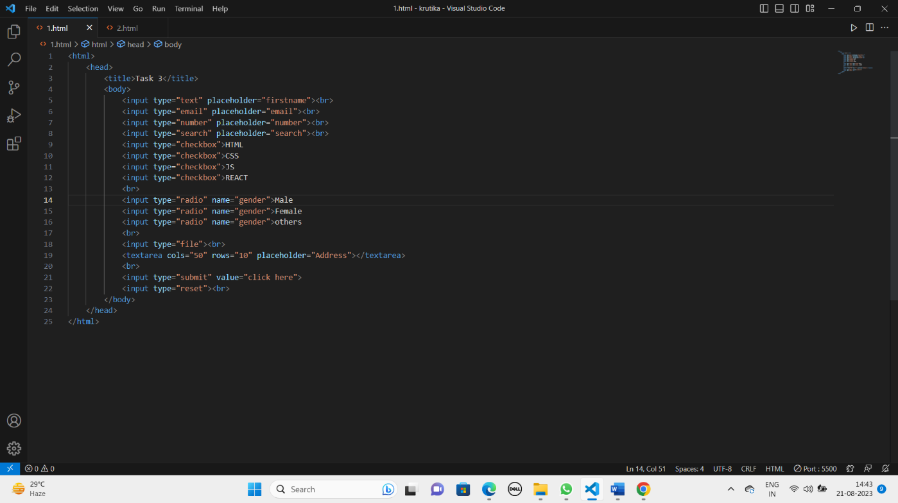

* **Output:**

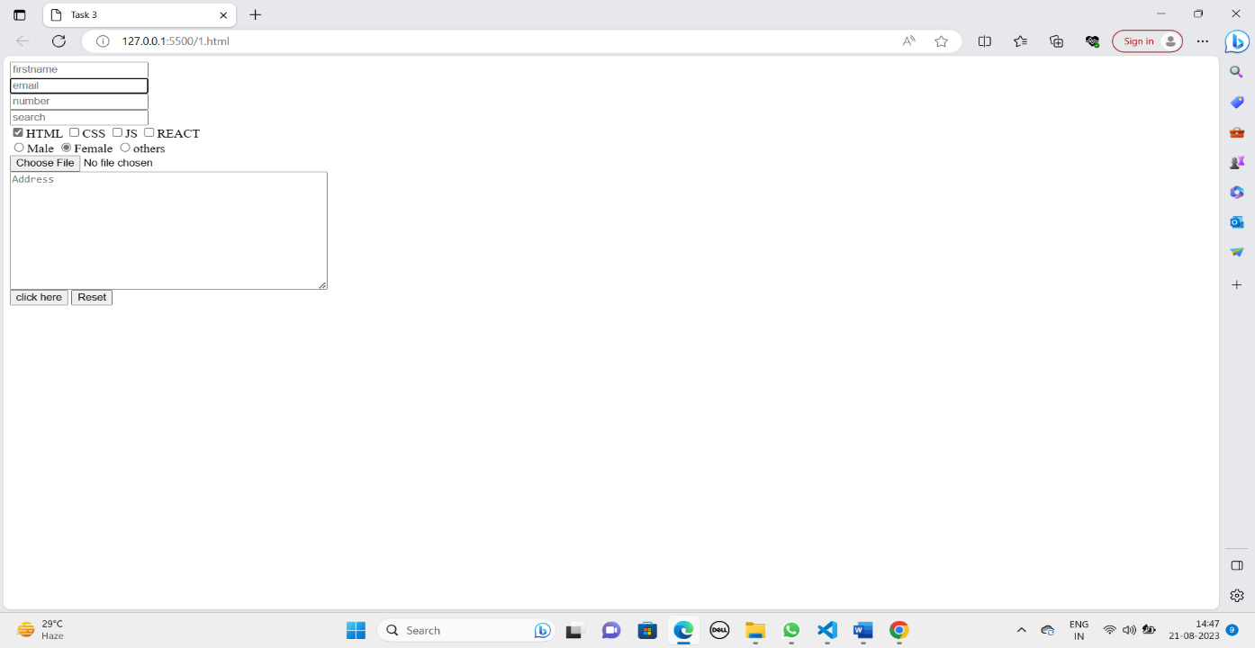

* **Discription:**
* Text Input: <input type="text">: Used for single-line text input.
* Password Input: <input type="password">: Similar to text input but hides the entered characters for security.
* Email Input: <input type="email">: Designed for email addresses and often includes validation for email format.
* Number Input: <input type="number">: Accepts numeric input and can include min and max attributes to specify allowable ranges.
* Date Input: <input type="date">: Allows the selection of a date from a calendar widget.
* Time Input: <input type="time">: Allows the selection of a time using a time picker.
* Datetime Input: <input type="datetime">: Allows the selection of both date and time.
* Checkbox: <input type="checkbox">: Provides a checkbox that can be selected or deselected.
* Radio Button: <input type="radio">: Used for a set of mutually exclusive options where only one can be selected.
* File Input: <input type="file">: Allows users to upload files from their device.
* Submit Button: <input type="submit">: Submits the form when clicked.
* Reset Button: <input type="reset">: Resets the form to its initial values when clicked.
* Button: <input type="button">: A generic button that can trigger JavaScript functions.
* Color Input: <input type="color">: Provides a color picker to select a color.
* Search Input: <input type="search">: Designed for search input fields.
* URL Input: <input type="url">: Designed for website URL input.
* Month Input: <input type="month">: Allows the selection of a specific month and year.
* Week Input: <input type="week">: Allows the selection of a specific week and year.
* Textarea: <textarea></textarea>: Provides a multi-line text input field.

# DAY 4

**DATE:** 14/08/23

**DAY:** Monday

* **Details of activity performed:**
* **Task:** Create four divisions and apply float property to them using HTML and CSS and arrange them in 2*2 form.
* **Code:**

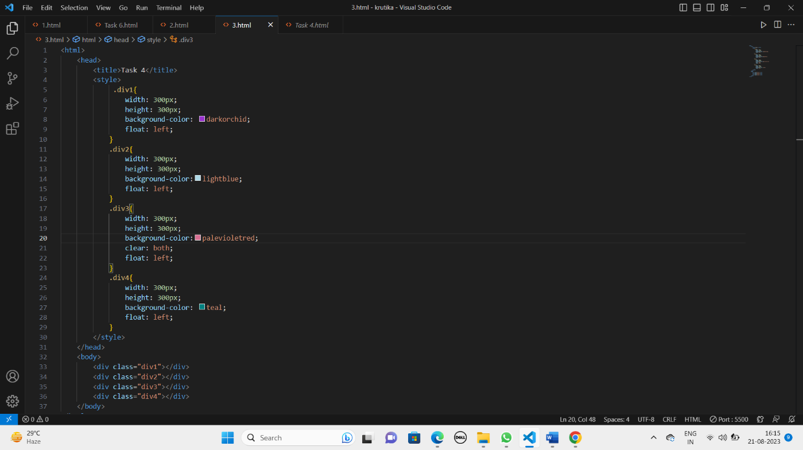

* **Output:**

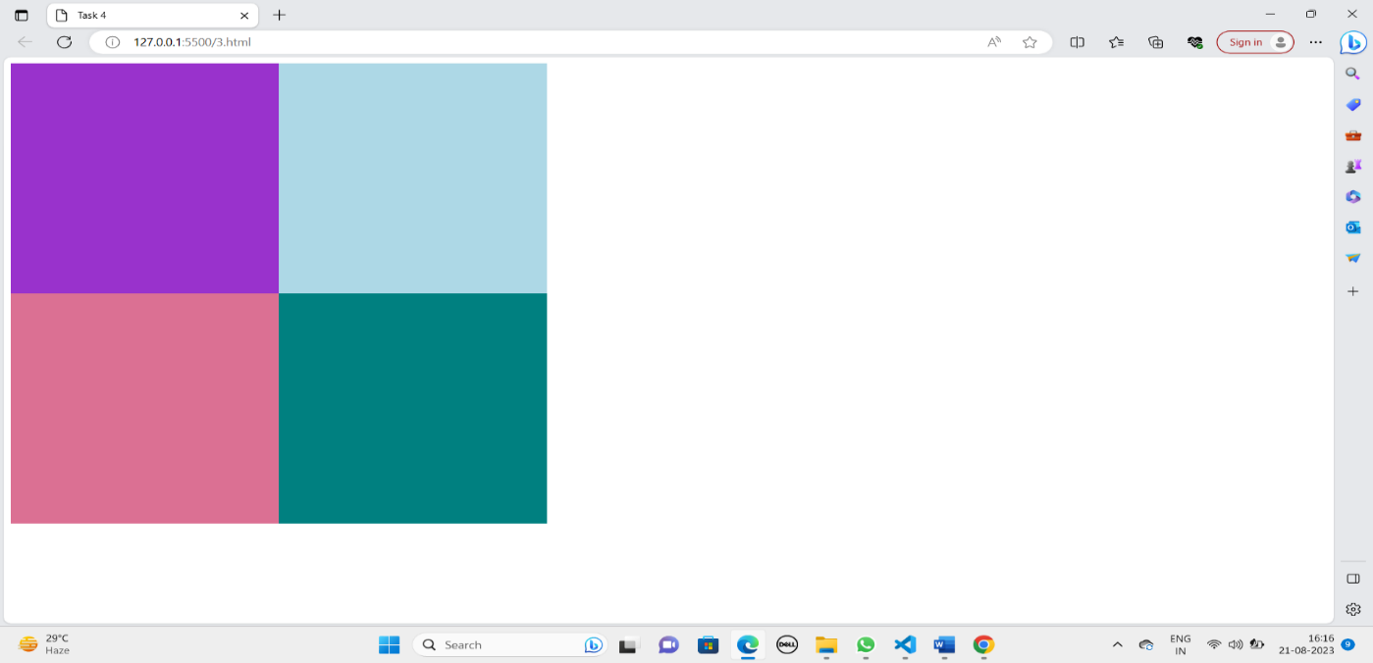

* **Discription:**
* class Attribute: The class attribute is used to assign one or more class names to an HTML element. Classes are a way to group elements together and apply styles to them collectively using CSS.
* style Attribute: The style attribute is used to add inline CSS styles directly to an HTML element. It can be used to set various CSS properties, including height, width, and float.
* Float (CSS Property): The float property is a CSS property that is used to specify how an element should be floated or positioned within its containing element.
* Common values for the float property:
* left: Floats the element to the left, and content flows around its right side.
* right: Floats the element to the right, and content flows around its left side.
* none (default): No floating. The element remains in the normal flow of the document.

# DAY 5

**DATE:** 15/08/23

**DAY:** Tuesday

* We have no session on 15th august due to public holiday.

# DAY 6

**DATE:** 16/08/23

**DAY:** Wednesday

* **Details of activity performed:**
* **Task:** To decorate text by CSS properties.
* **Code:**

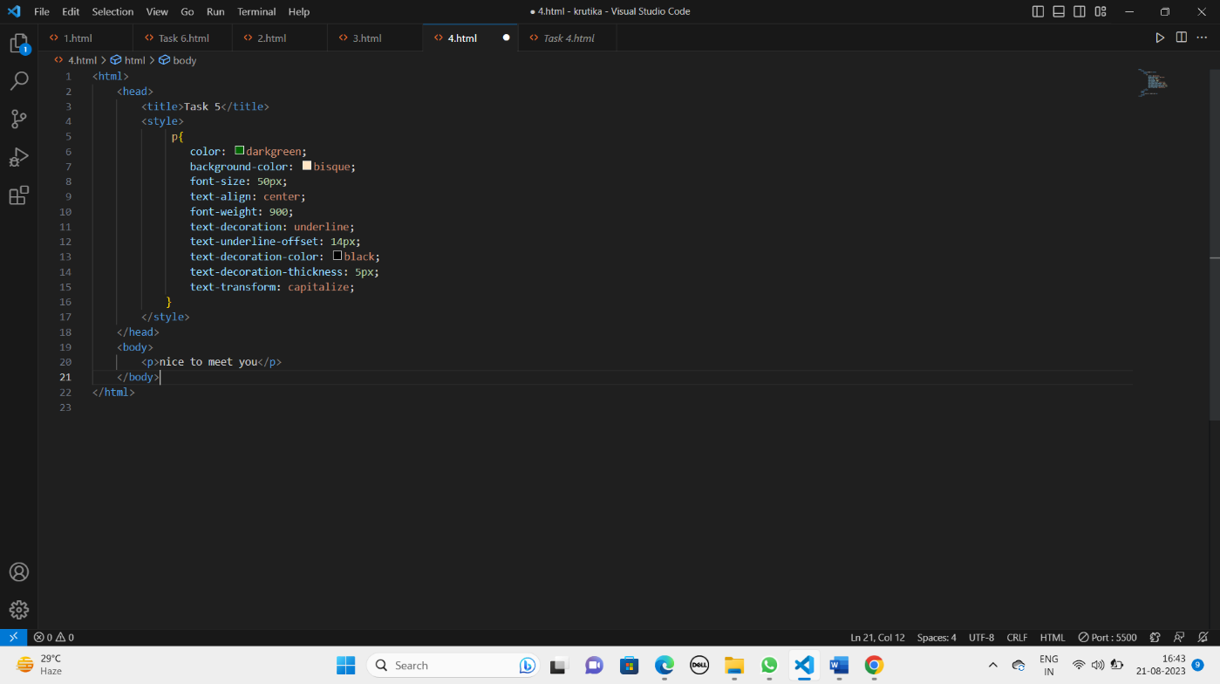

* **Output:**

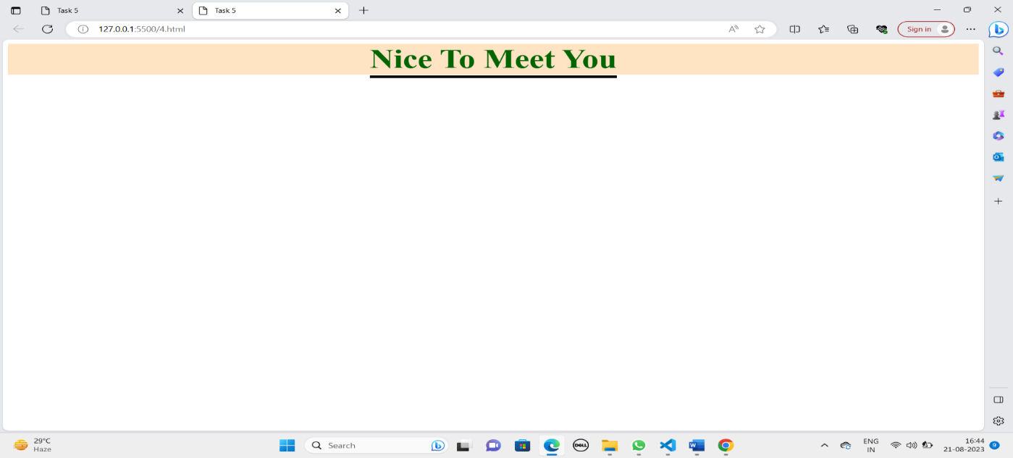

* **Discription:**
* Text-decoration: This property controls the overall text decoration for an element. It can have one or more values separated by spaces:
* none: No decoration (default).
* underline: Adds a line underneath the text.
* overline: Adds a line above the text.
* line-through: Adds a line through the text.
* Text-decoration-line: This property allows you to specify individual text decoration lines, which can be combined:
* none: No decoration (default).
* underline: Adds a line underneath the text.
* overline: Adds a line above the text.
* Text-decoration-style: This property defines the style of the text decoration lines:
* solid (default): A solid line.
* dotted: A series of dots.
* dashed: A series of short dashes.
* Text-decoration-thickness: This property sets the thickness of the text decoration lines.
* Text-underline-offset: This property controls the position of the underline.
* Text-transform: It allows you to change the way text is displayed.
* uppercase: Transforms all characters to uppercase.
* lowercase: Transforms all characters to lowercase.
* capitalize: Capitalizes the first letter of each word.
* none (default): No transformation is applied. Text is displayed as it is in the HTML.

**Name and signature of student Name and signature of external guide**

Malvi Krutika Rasheshbhai Mr. Sagar Jasani

 

# SAL INSTITUTE OF DIPLOMA STUDEIS

## DEPARTMENT OF COMPUTER ENGINEERING DEPARTMENT OF INFORMATION TECHNOLOGY

**WEEK 2**

### FROM DATE: 16/08/23 TO DATE: 23/08/23

# DAY 1

**DATE:** 17/08/23

**DAY:** Thursday

* **Details of activity performed:**
* **Task:** Set 9 images of same size in a screen using CSS properties.
* **Code:**

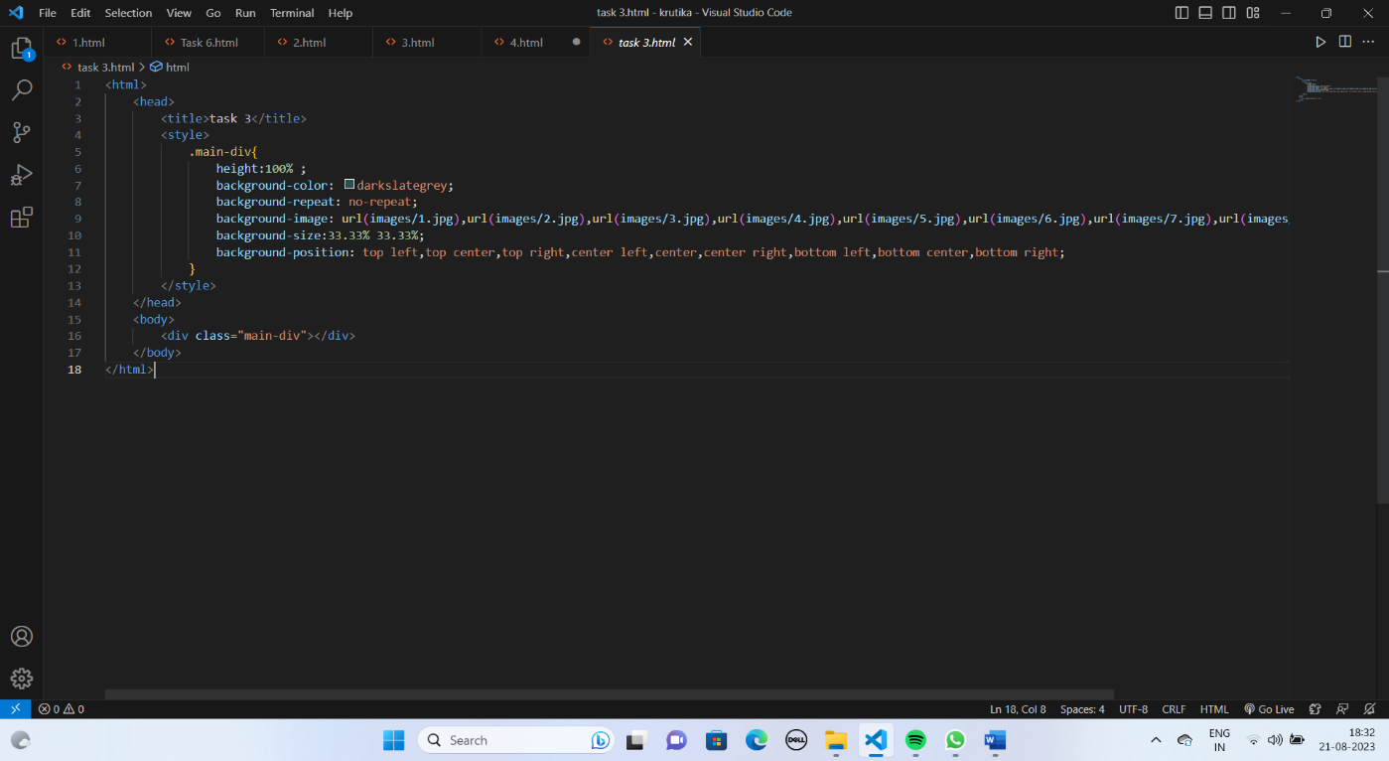

* **Output:**

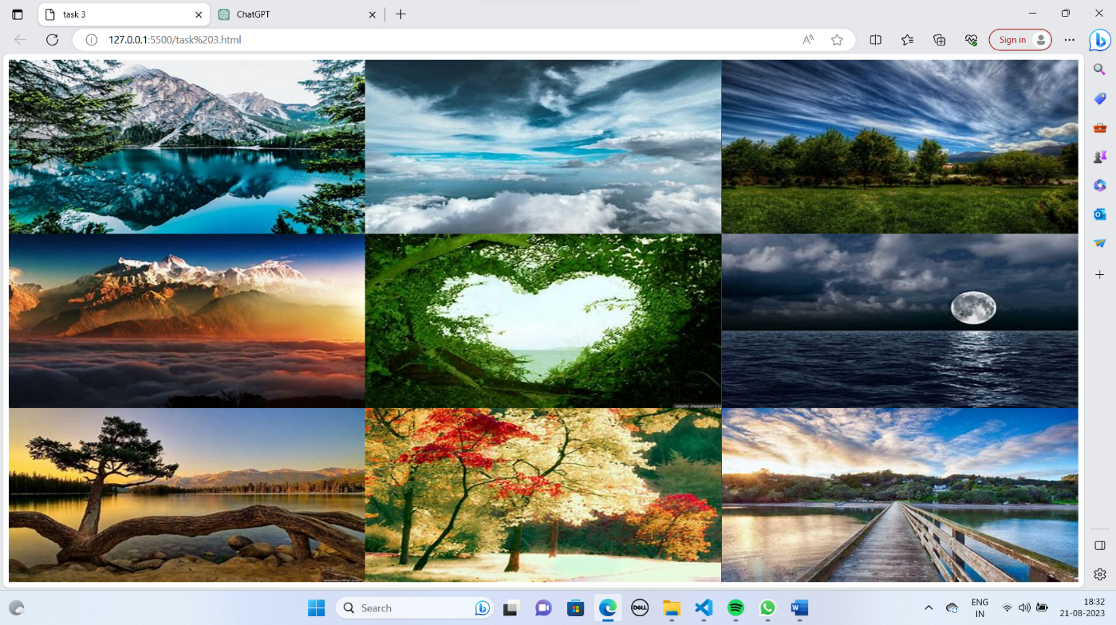

* **Discription:**
* Background-image: This property allows you to specify an image to be used as the background for an element.
* Background-position: This property determines where the background image is positioned within its containing element. You can use keywords like center, top, bottom, left, and right, or specific pixel values and percentages to set the position.
* Background-size: The background-size property specifies the size of the background image. You can set it to a specific width and height using pixel values, percentages.
* Common values include repeat (default), no-repeat, repeat-x, and repeat-y.
* center: Positions the background image in the center.
* top: Positions the background image at the top.
* cover: Scales the image to cover the entire element, cropping as needed.
* contain: Scales the image to fit within the element's box, maintaining its aspect ratio.
* no-repeat: Prevents the background image from repeating.
* repeat-x: Repeats the background image horizontally.
* repeat-y: Repeats the background image vertically.

# DAY 2

**DATE:** 18/08/23

**DAY:** Friday

* **Details of activity performed:**
* **Task:** Create 3 product cards using CSS.
* **Code:**

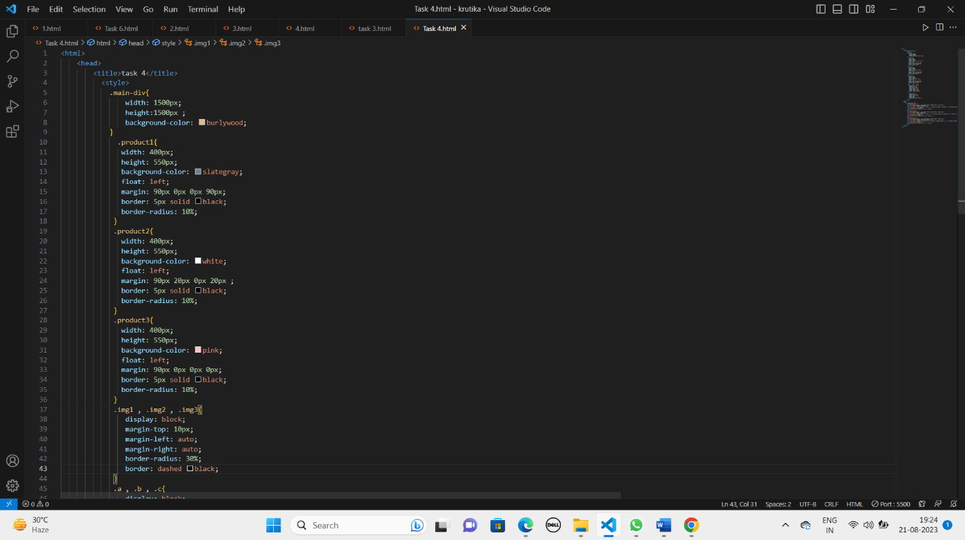

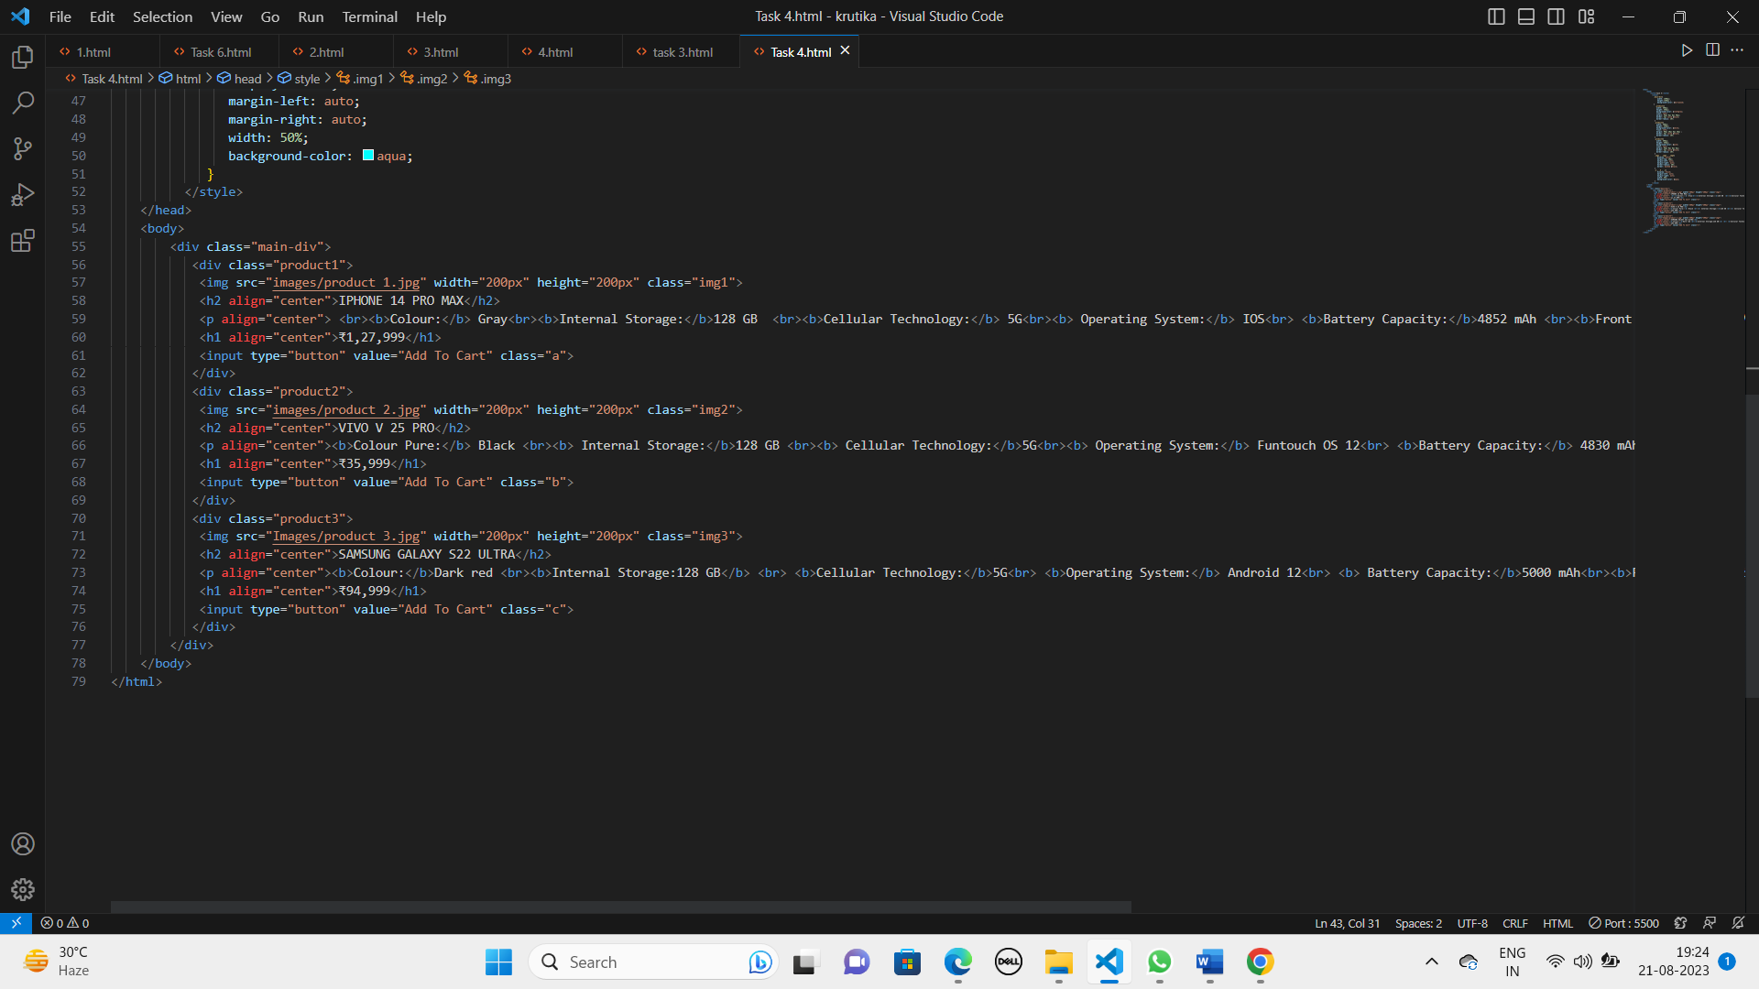

* **Output:**

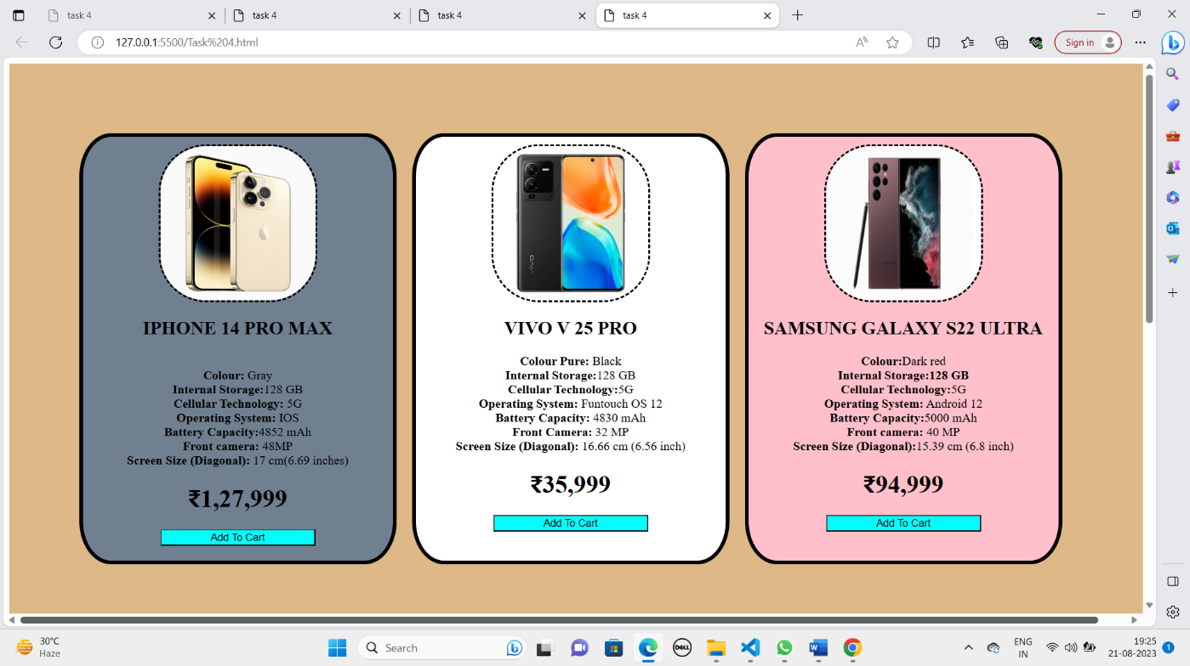

* **Discription:**
* Margin: This property is used to control the space outside the element border. It creates space around the element, pushing other element away.
* Border-radius : This property is used to round the corners of an element , giving it a curved appearance.
* Display-block: This property changes the display behavious of an element to a block level element . Block-level element take up the full width of the container and start on a new line.
* <button>: This element is used to create clickable buttons that user can interact with.
* <img>: This element is used to display images on a webpage. The src attribute specifies the URL of the image file to be displayed.

# DAY 3

# 

**DATE:** 19/08/23

**DAY:** Saturday

* **Details of activity performed:**
* **Task:** Create a nav bar from which we can change the background and font colour of the content on hover using CSS.
* **Code:**

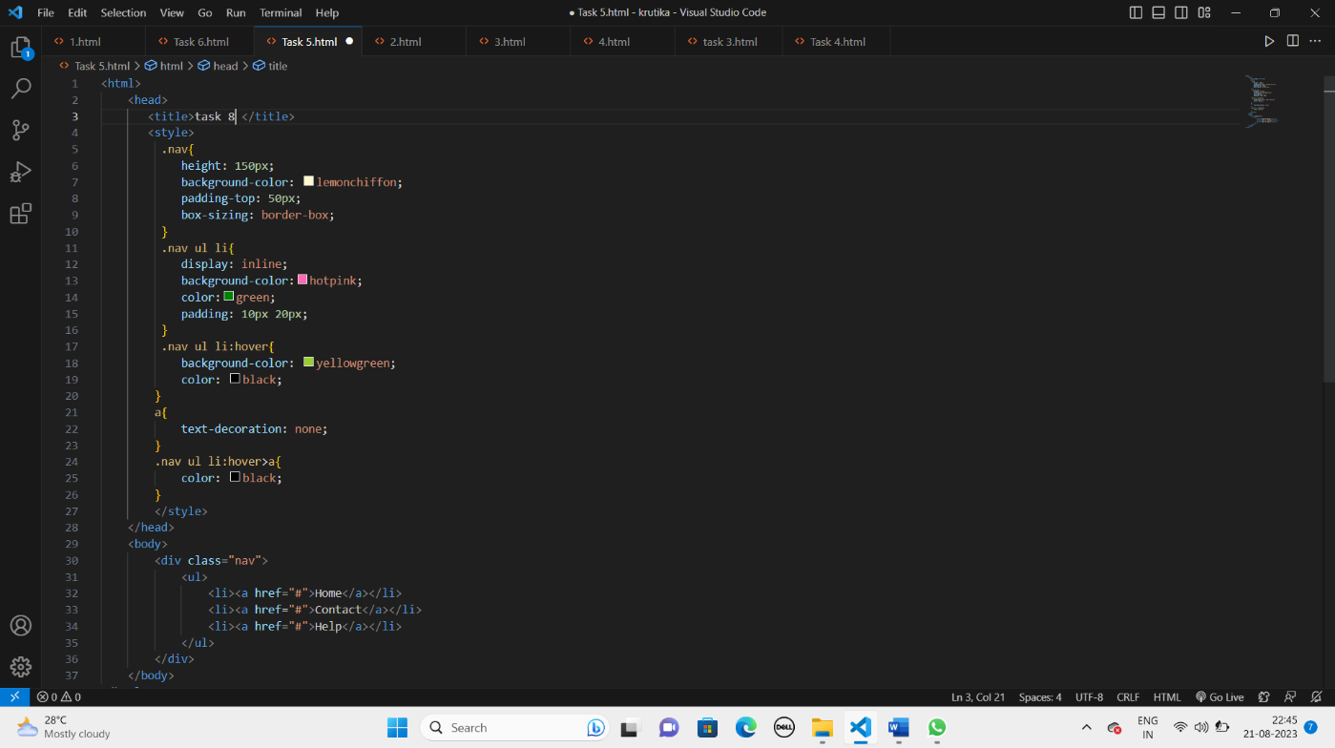

* **Output:**

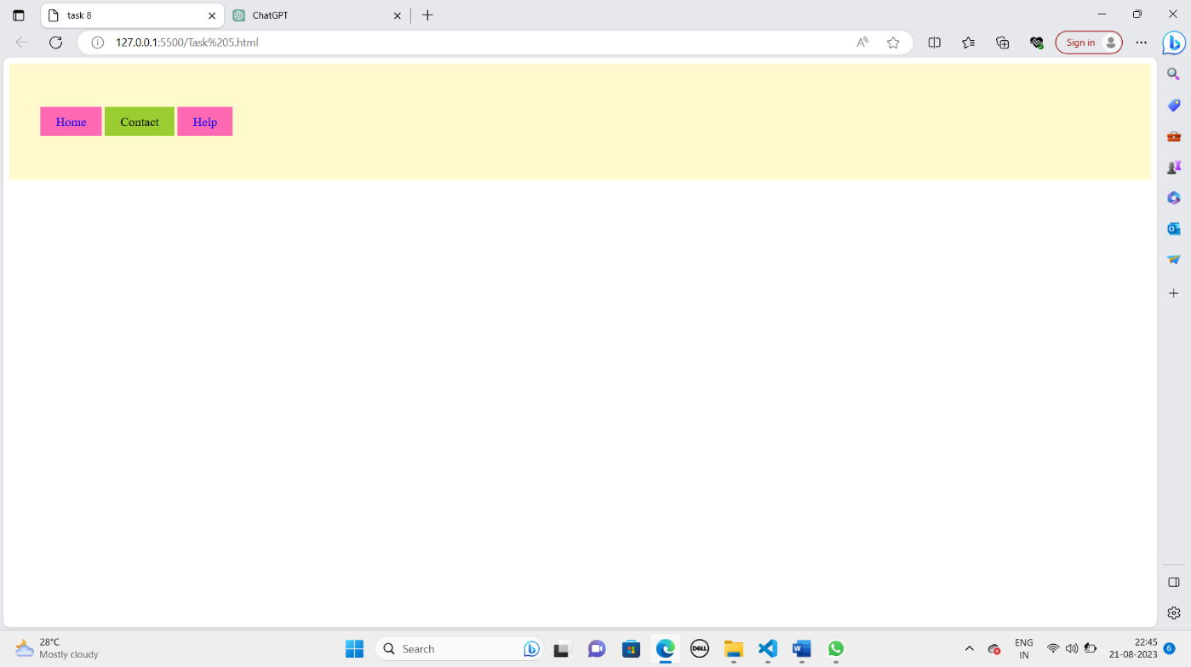

* **Discription:**
* Padding: This property is used to control the space between an element’s contents and its border.It creates space within the element.
* Box-sizing: This property defines how the total width and height of an element are calculated, including its padding and border.
* Box-sizing: border-box: includes padding and border in the specified width and height.
* Hover: It is used to apply styles to an element when a user hovers their mouse cursor over it.
* Display: inline: This property changes an element’s display behaviour to inline. Inline elements flow within the text content and don’t start on a new line.
* <a>: This element is used to create hyperlinks.
* The href attribute specifies the URL to link t.
* Using href = ”#” creates an internal link that navigates to the top of the same page.

# DAY 4

**DATE:** 21/08/23

**DAY:** Monday

* **Details of activity performed:**
* **Task:** Create 5 drop down list with more sub options which are hidden and can be seen on hover using CSS.
* **Code:**

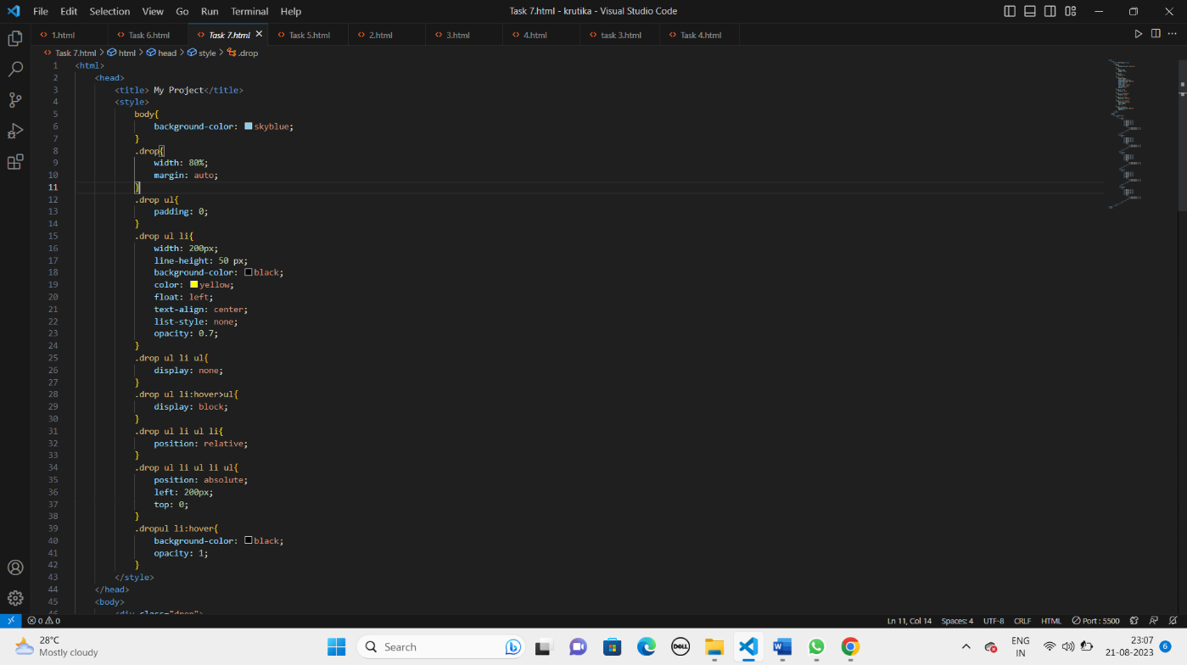

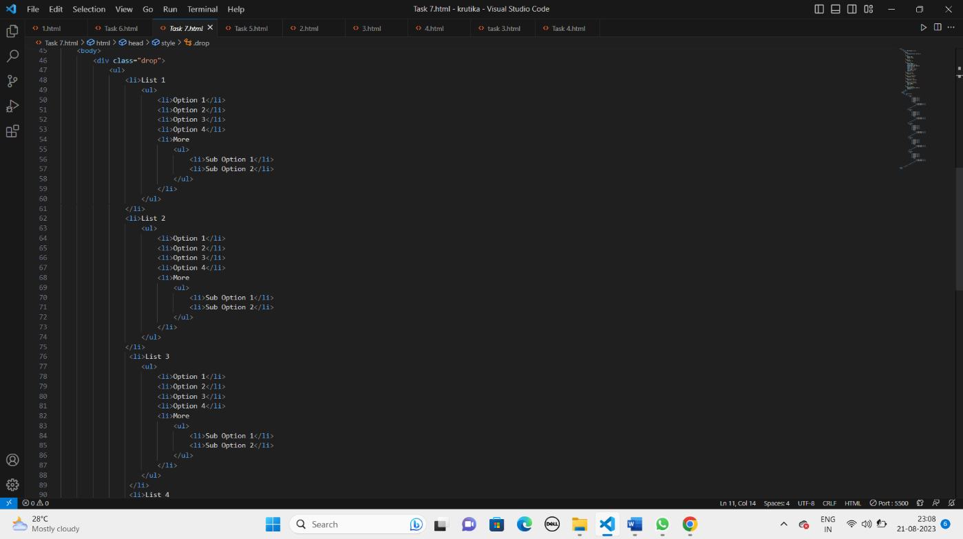

* **Output:**

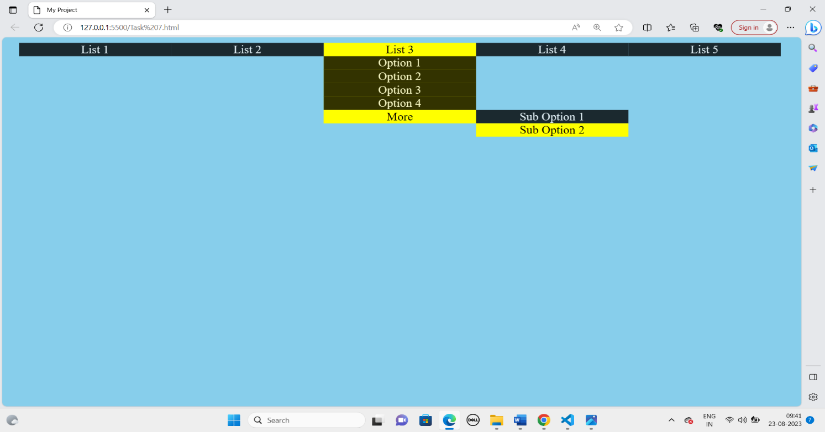

* **Discription:**
* Line Height (line-height): Line height is a CSS property that defines the amount of vertical space between lines of text within an element.
* Opacity (opacity): Opacity is a CSS property that controls the transparency of an element. It ranges from 0 (completely transparent) to 1 (fully opaque).
* List Style (list-style): The list-style property in CSS is used to specify the style of the list marker (bullet or number) in a list item.
* Unordered List (<ul>): An unordered list is an HTML element used to create a list of items where the order of the items does not matter. It's typically used with list items (<li>).
* Ordered List (<ol>): An ordered list is an HTML element used to create a list of items where the order of the items is important. It's typically used with list items (<li>) and automatically numbers the list items.

# DAY 5

**DATE:** 22/08/23

**DAY:** Tuesday

* **Details of activity performed:**
* **Task:** Create six divisions and apply media query CSS properties and arrange them in 2*3 form.
* **Code:**

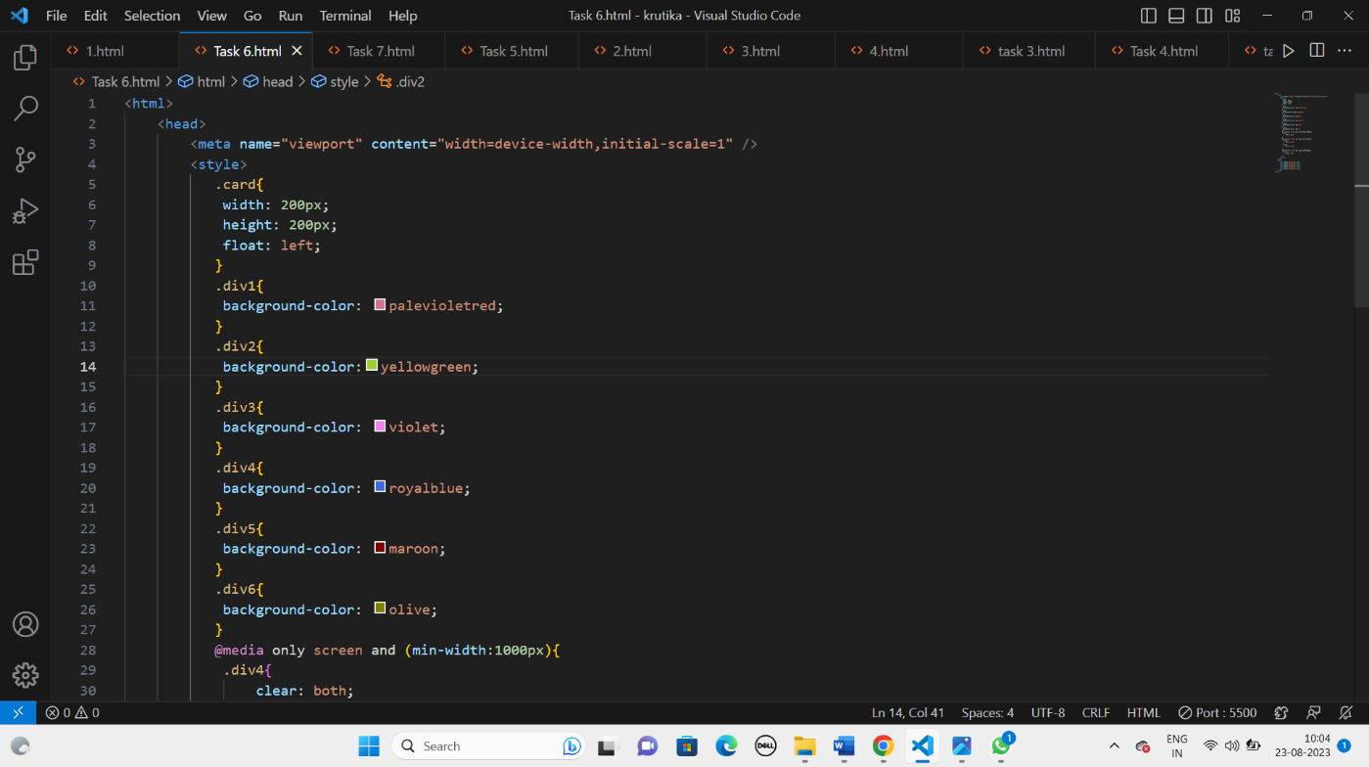

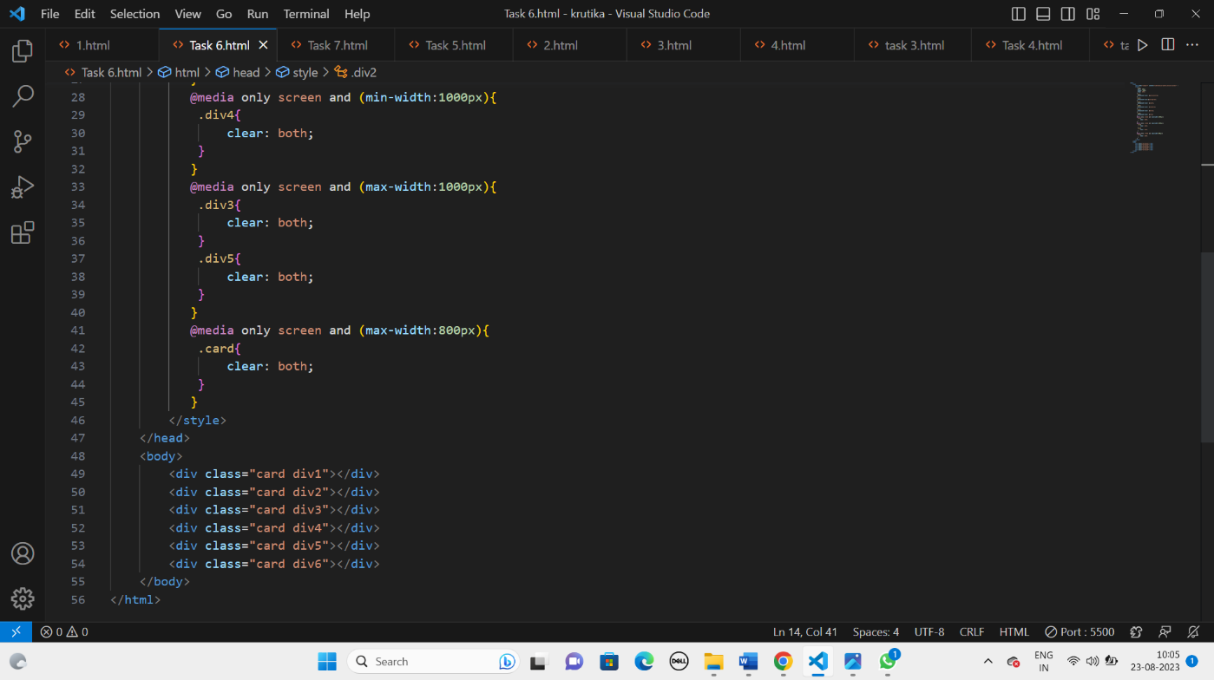

* **Output:**

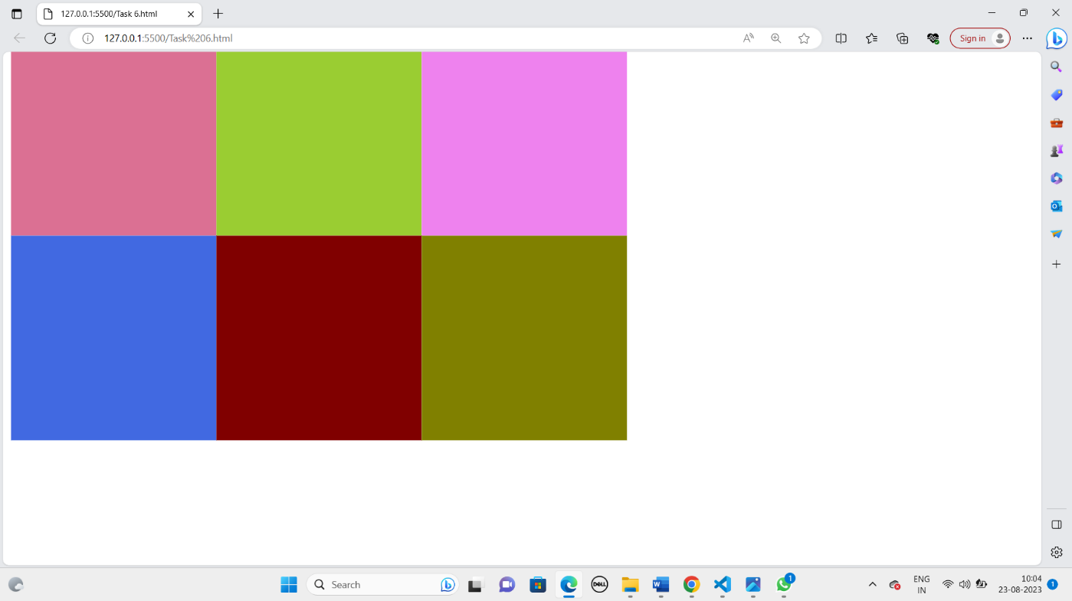

* **Discription:**
* <meta> : The <meta> tag you provided is used to define the viewport settings for a web page. This tag is important for making web pages responsive to various screen sizes, especially on mobile devices.
* Media queries: Media queries are a fundamental component of responsive web design.
* This enables web designers and developers to create websites that adapt and look good on a wide range of devices, from small mobile phones to large desktop monitors.
* Media queries are written inside CSS files or in a <style> block within an HTML document.
* Syntax: Media queries use the @media rule, followed by one or more conditions enclosed in parentheses. The conditions specify when the styles inside the media query should be applied.

# DAY 6

**DATE:** 23/08/23

**DAY:** Wednesday

* **Details of activity performed:**
* **Task:** Create a responsive page using Bootstrap, Java-script, Carousel and CSS.
* **Code:**

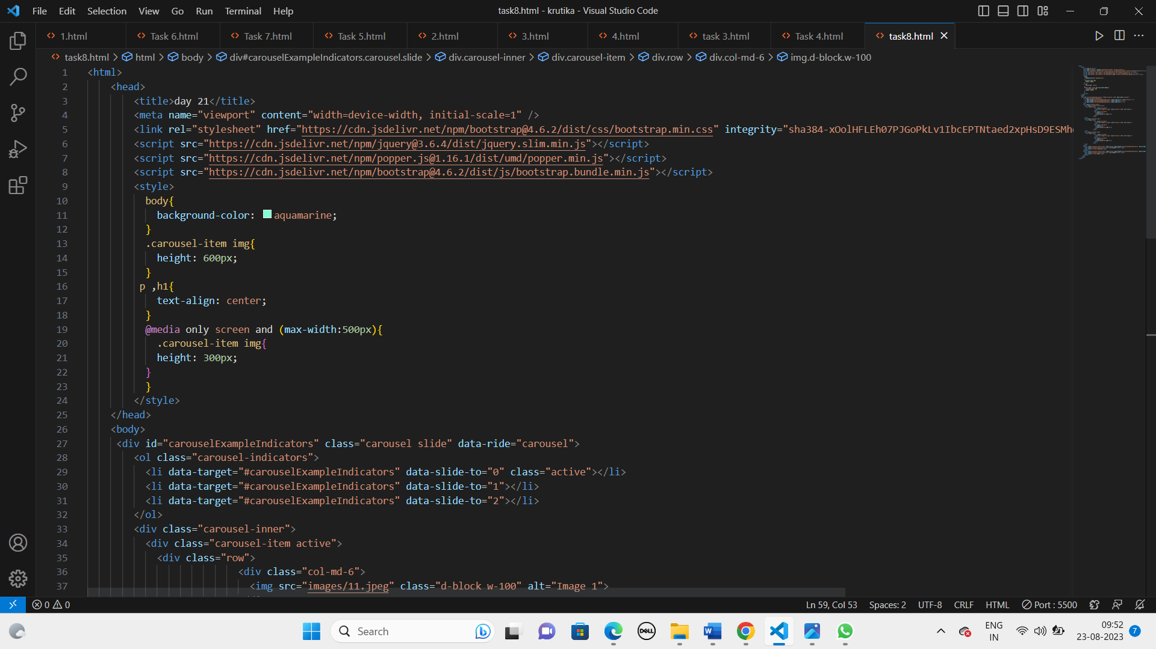

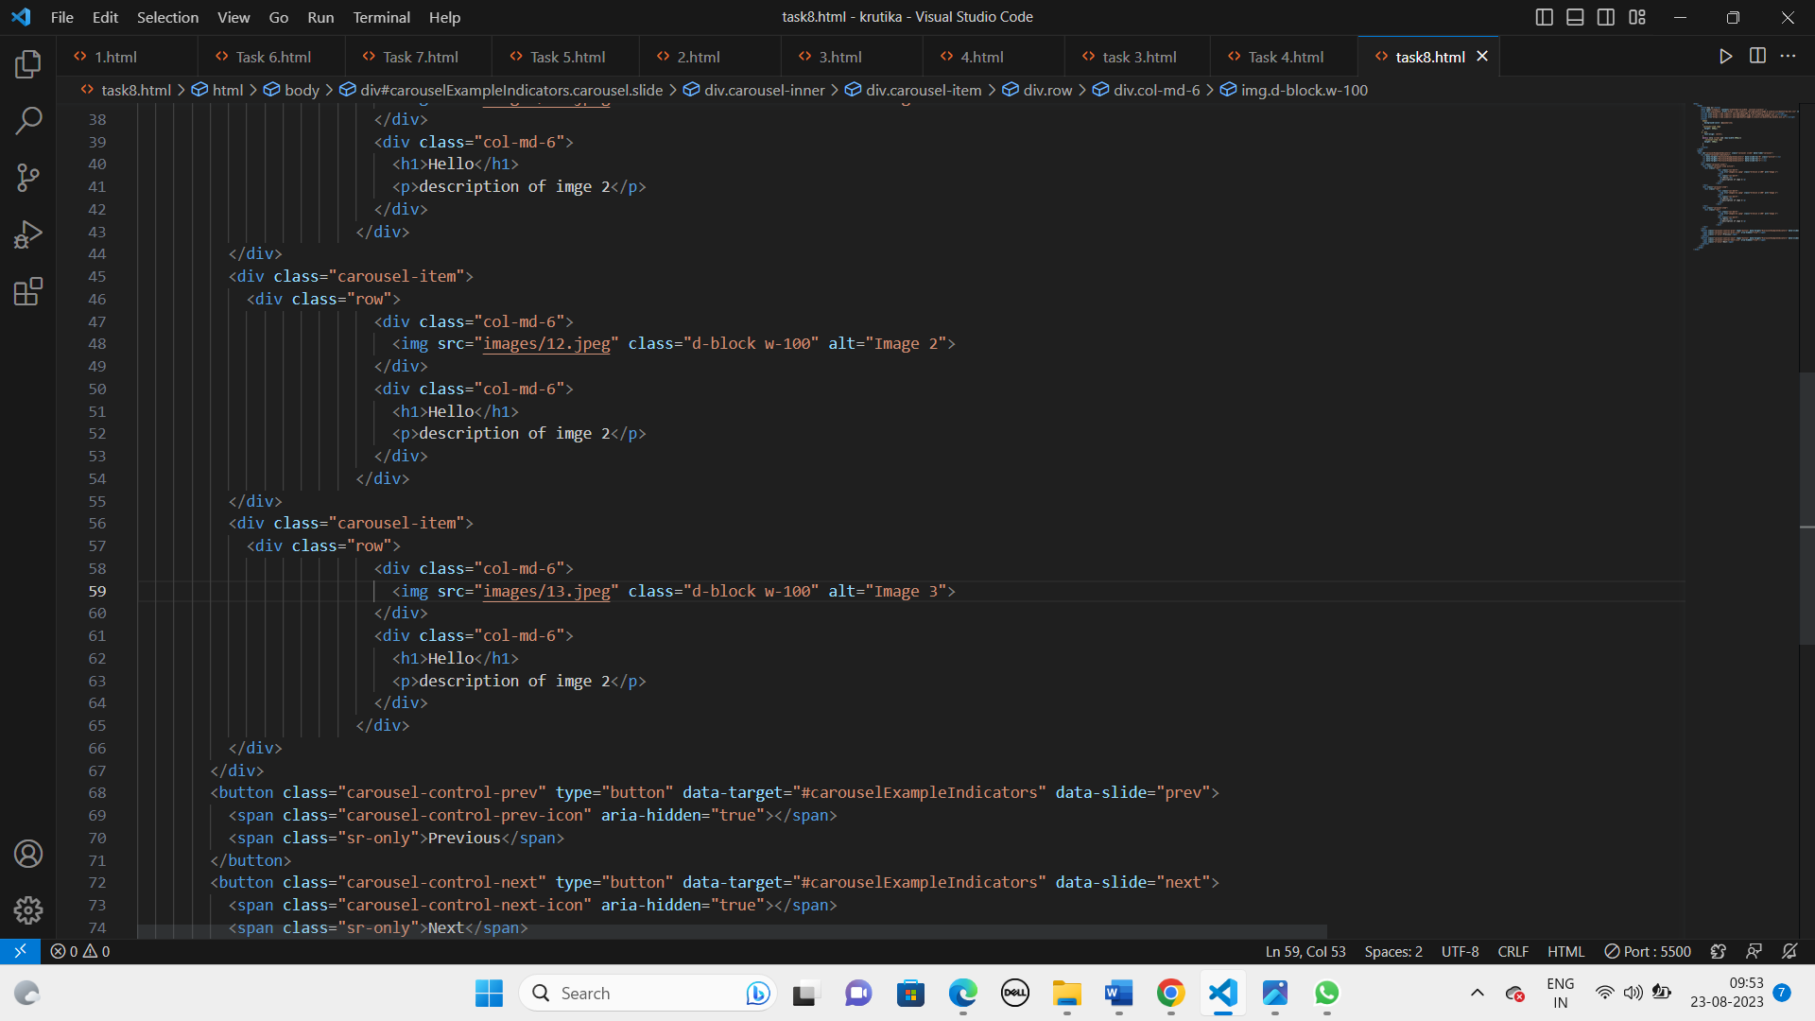

* **Output:**

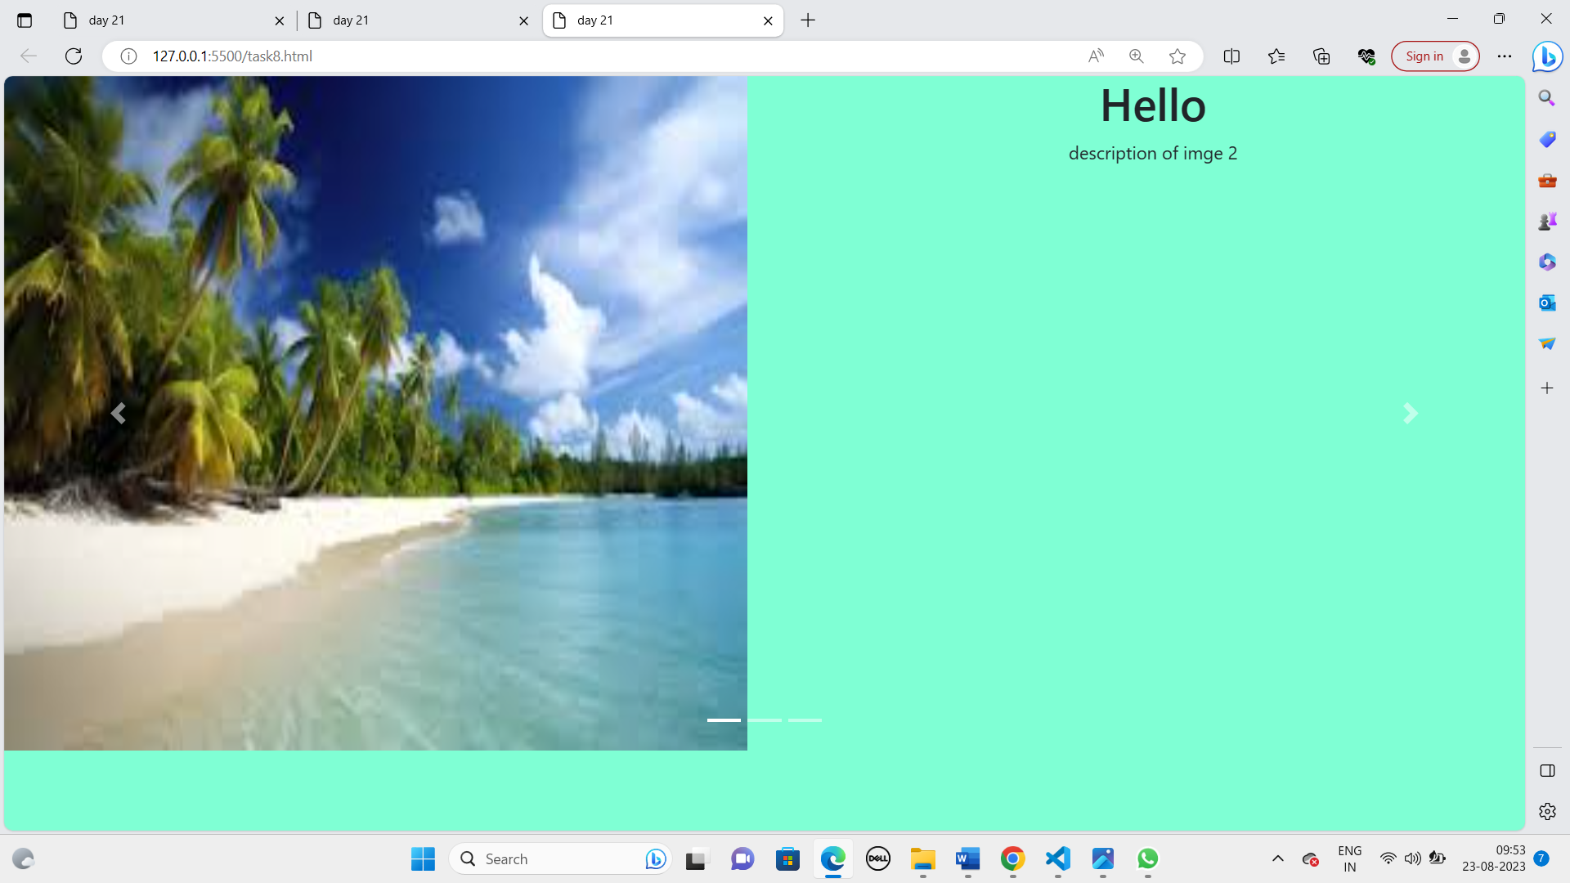

* **Discription:**
* Carousel: A carousel, in web design, is a user interface element that displays a rotating set of images or content in a continuous loop.
* Carousels are used to showcase multiple pieces of content, such as images, products, news articles, testimonials, or any other information that can be presented in a slideshow format.
* Bootstrap: A bootstrap is an open-source front-end web development framework originally created by Twitter. It's a collection of pre-designed HTML, CSS, and JavaScript components and tools that make it easier to create responsive websites and web applications.
* Bootstrap includes various components and utilities, such as a grid system, typography, forms, buttons, navigation bars, modals, and carousels,
* The <script> tag in HTML is used to embed or reference external JavaScript code within an HTML document. The <script> tag allows you to include JavaScript code in your HTML pages, either directly within the HTML file or by linking to external JavaScript files.

**Name and signature of student Name and signature of external guide**

Malvi Krutika Rasheshbhai Mr. Sagar Jasani

 